**KWAME NKRUMAH UNIVERSITY OF SCIENCE AND TECHNOLOGY**

**CHEMICAL ENGINEERING DEPARTMENT**

**CHE 158: INTRODUCTION TO INFORMATION TECHNOLOGY**

**INSTRUCTOR:** Dr. (Mrs.) Mizpah A. D. Rockson

LECTURE 2: **THE INTERNET AND THE WEB**

**Learning Objectives**

At the end of the lecture the student is expected to understand the following:

1. Explain the origins of the Internet and the web.
2. Explain how to access the web using providers and browsers.
3. Compare different web utilities, including plug-ins, filters, file transfer utilities, and Internet security suites.
4. Compare different Internet communications, including e-mail, text messaging, instant messaging, social networking, blogs, microblogs, webcasts, podcasts, and wikis.
5. Describe search tools, including search engines and specialized search engines.
6. Evaluate the accuracy of information presented on the web.
7. Identify electronic commerce, including B2C, C2C, B2B, and security issues.
8. Describe cloud computing, including the three-way interaction of clients, Internet, and service providers.

Do you want to communicate with a friend in another town or in another country? Would you like to send a drawing, a photo, or just a letter? Are you looking for travel or entertainment information? Perhaps, you want to research an assignment. Where do you start? Try the Internet and the Web.

The Internet is often referred to as the Information Superhighway moving ideas and information through **cyberspace**. Competent end users need to be aware of the resources available on the Internet and the Web. Additionally, they need to know how to access these resources, to effectively communicate electronically, to efficiently locate information, to understand electronic commerce, and to use the Web utilities.

**2.1 Beginnings**

The Internet, or Net, was launched in 1969 when the United States funded a major research project on computer networking. A national computer network called **Advanced Research Project Agency Network** (**ARPANET**) was developed. It was used by government and military agencies to communicate and share computer resources with researchers working on national security projects. The Internet evolved from these military and research beginnings.

The **Web**, also known as **WWW** and the **World Wide Web**, was introduced in 1992 at the **Center for European Nuclear Research** (**CERN**) in Geneva, Switzerland. Prior to the Web, the Internet was all text – no graphics, animations, sound, or video. The Web provided a multimedia interface to resources available on the Internet. From these research beginnings, the Internet and the Web evolved into one of the most powerful tools of the 21st century.

It is easy to get the Internet and the Web confused, but they are not the same thing. The Internet is the actual physical network. It is made up of wires, cables, and satellites. Being connected to this network is described as being **online**. The Internet connects over 6 billion computers and resources throughout the world. The Web is a multimedia interface to the resources available on the Internet. Every day over a billion users from all around the world use the Internet and the Web.

**2.2 Internet applications**

The most common Internet applications are:

* **Communicating**: is by far the most popular Internet activity. You can exchange e-mail with your family and friends almost anywhere in the world. You can join and listen to discussions and debates on a wide variety of special-interest topics.
* **Shopping**: is one of the fastest-growing Internet applications. You can window shop, look for the latest fashions, search for bargains, and make purchases.
* **Researching**: for information has never been more convenient. You can access some of the world’s largest libraries directly from your home computer. You can find the latest local, national, and international news.
* **Education or e-learning**: is another rapidly emerging Web application. You can take classes on almost any subject. There are courses just for fun and there are courses for high school, college, and graduate school credit. Some cost nothing to take and others cost a lot.
* **Entertainment**: You can find music, movies, magazines, and computer games. You will find live concerts, movie previews, book clubs, and interactive live games.

The first step to using the Internet and the Web is to get connected, or to gain access to the Internet.

**2.3 Access**

Providers give us access to the Internet. Browsers provide access to Web resources.

**2.3.1 Providers**

The most common way to access the Internet is through a **Commercial Internet service** **provider (CISP).** The providers are already connected to the Internet and provide a path or connection for individuals to access the Internet.

2 widely known Internet providers:

* **Universities/Institutions**: Most colleges, universities or institutions provide free access to the Internet through their local area networks (LAN).
* **Internet service providers**: offer access to the Internet for a fee. They include national and wireless service providers. National service providers provide access through standard telephone lines. Wireless service providers provide connections with wireless modems and a wide variety of wireless devices. They do not use telephones lines. In Ghana, almost all telecommunication companies are Internet providers.

**2.3.2 Browser**

Browsers are programs that provide access to Web resources. This software connects you to remote computers, opens and transfers files, displays text and images, and provides in one tool an uncomplicated interface to the Internet and Web documents. Browsers allow you to explore, or to **surf,** the Web by easily moving from one Web site to another. Four well known browsers are Mozilla Firefox, Apple Safari, Microsoft Internet Explorer, and Google Chrome.

- **Addresses:** For browsers to connect to resources, the **location** or **address** of the resources must be specified. These addresses are called **uniform resource locators (URLs).** All URLs have at least two basic parts. The first part presents the protocol used to connect to the resource. **Protocols** are rules for exchanging data between computers. The protocol ***http***is used for Web traffic and is the most widely used Internet protocol. The second part presents the **domain** **name.** It indicates the specific address where the resource is located.

An example is shown below. Many URLs have additional parts specifying directory paths, file names, and pointers.) The last part of the domain name following the dot (.) is the **top-level domain (TLD).** It identifies the type of organization. For example, *.com* indicates a commercial site. The URL *http://www.mtv.com* connects your computer to a computer that provides information about MTV.



|  |  |
| --- | --- |
| Domain | Organization type |
| .com  .edu  .gov  .org  .mil  .net | Commercial  Educational  Government  Other organization  US Military  Network |

**Table 2.1 Top-level domains**

**-Web pages**: Once the browser has connected to the Web site, a document file is sent back to your computer. This document contains **Hypertext Markup Language** **(HTML)** commands. The browser interprets the HTML commands and displays the document as a Web page. The first page at a Web site is referred to as the **home page**. The home page presents information about the site along with references and **hyperlinks** or **links** that connect to other documents containing related information—text files, graphic images, audio, and video clips.

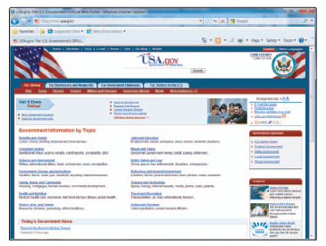

**Figure 2.1 Web page**

These documents may be located on a nearby computer system or on one halfway around the world. The computer that stores and shares these documents is called a **Web server**. The links typically appear on the Web page as underlined and colored text and/or images. When your mouse passes over a link, the mouse pointer changes to the shape of a small hand. To access the referenced material, all you do is click on the highlighted text or image. A connection is automatically made to the computer containing the material, and the referenced material appears on your display screen.

Web pages can also contain links to special programs, called **applets** that are typically written in **Java** programming language. These programs can be quickly downloaded and run by most browsers. Java applets are widely used to add interest and activity to a Web site by presenting animation, displaying graphics, providing interactive games and so on.

**2.4 Communication**

Communication is the most popular Internet activity and its impact cannot be overestimated. Some popular types of Internet communication are e-mail, instant messaging, social networking, blogs, and wikis.

**2.4.1 E-mail**

**E-mail** or **electronic mail** is the transmission of electronic messages over the Internet. All you need to send and receive e-mail is an e-mail account, access to the Internet, and an e-mail program. Two of the most widely used e-mail programs are **Microsoft’s Outlook Express** and **Mozilla Thunderbird**.

A typical e-mail message has three basic elements: header, message, and signature.

(1) **Header** appears first and typically includes the following information:

* **Addresses**: Addresses of the persons sending, receiving, and, optionally, anyone else who is to receive copies. E-mail addresses have two basic parts. The first part is the user’s name and the second part is the domain name, which includes the top-level domain.



The domain name is a reference to a particular organization. The user name identifies a

unique person or computer at the listed domain.

* **Subject**: A one-line description, used to present the topic of the message. Subject lines typically are displayed when a person checks his or her mailbox.
* **Attachments**: Many e-mail programs allow you to attach files such as documents, spreadsheet, and image files. If a message has an attachment, the file name typically appears on the attachment line.

(2) **Message**

(3) **Signature:** The **signature** provides additional information about the sender. This information

may include the sender’s name, address, and telephone number.

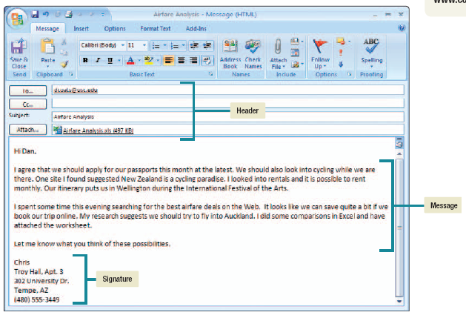

**Figure 2.2: Basic elements of an email message**

Users receive billions of unwanted and unsolicited e-mails every year. This unwelcome mail is called **spam**. Spam is not only a nuisance, but it can also be dangerous. **Computer viruses** or destructive programs are often attached to unsolicited e-mail.

The use of **spam blockers,** also known as **spam filters** are effective in dealing with computer viruses. These programs use a variety of different approaches to identify and eliminate spam.

|  |  |
| --- | --- |
| **Spam blocker** | **Site** |
| SPAMfighter  SpamEater  Spam Buster | [www.spamfighter](http://www.spamfighter).com  [www.spameater](http://www.spameater).com  [www.spambuster](http://www.spambuster).com |

**Table 2.2 Spam blockers**

**2.4.2 Instant messaging**

**Instant messaging (IM)** allows two or more people to contact each other via direct, live communication. To use instant messaging, you register with an instant messaging server and then specify a list of **friends.** Whenever you connect to the Internet, special software informs your messaging server that you are online. In response, the server will notify you if any of your friends are online. At the same time, it notifies your friends that you are online. You can then send messages directly back and forth to one another. Most instant messaging programs also include video conferencing features, file sharing, and remote assistance.

The most widely used instant messaging services are AOL’s Instant Messenger, Microsoft’s MSN Messenger, and Yahoo Messenger.

One limitation, however, is that many instant messaging services do not support communication with other services.

Recently, however, some software companies have started providing **universal instant messenger** programs that overcome this limitation. Three widely used programs are **Digsby**, **Pidgin**, and **Qnext**.

**2.4.3 Social Networking**

One of the fastest-growing uses of the Internet is **social networking,** or connecting individuals to one another. While many social networking sites support a wide range of activities, there are three broad categories: reuniting, friend-of-a-friend, and common interest.

* **Reuniting:** are designed to connect people who have known one another but have lost touch; for example, an old high school friend that you have not seen for several years. You join a social network by connecting to a reuniting site and providing profile information such as your age, gender, name of high school, and so forth. This information is added to the reuniting site’s member database. Members are able to search the database to locate individuals. Many of the sites will even notify you whenever a new individual joins that matches some parts of your profile (such as high school class). Two of the best-known reuniting sites are **Classmates Online** and **Facebook**.
* **Friend-of-a-friend:** are designed to bring together two people who do not know one another but share a common friend. The theory is that, if you share a common friend, then it is likely that you would become friends. Two well-known friend-of-a-friend sites are **Friendster** and **MySpace**.
* **Common interest sites:** bring together individuals that share common interests or hobbies. You select a networking site based on a particular interest. For example, if you wanted to share images, you might join **Flickr** or **YouTube**. If you are looking for business contacts, you might join **Linkedln**. If you wanted to locate or create a special interest group, you might join **Meetup**.

**2.4.4 Blogs, Microblogs, and Wikis**

Aside social networking sites, people can communicate across the Web using blogs and wikis.

* **Blogs**: Many individuals create personal Web sites, called **Web logs** or **blogs,** to keep in touch with friends and family. Blog postings are timestamped and arranged with the newest item first. Often, readers of these sites are allowed to comment. Some blogs are like online diaries with personal information; others focus on information about a hobby or theme, such as knitting, electronic devices, or good books. Although most are written by individual bloggers, there are also group blogs with multiple contributors. Some businesses and newspapers also have started blogging as a quick publishing method. Several sites provide tools to create blogs. Two of the most widely used are **Blogger** and **WordPress**.
* **Microblogs:** A **microblog** publishes short sentences that only take a few seconds to write, rather than long stories or posts like a traditional blog. Microblogs are designed to keep friends and other contacts up-to-date on your interests and activities. The most popular microblogging site is **Twitter.**
* **Wikis**: A **wiki** is a Web site specially designed to allow visitors to fill in missing information or correct inaccuracies. Wikis support collaborative writing in which there isn’t a single expert author, but rather a community of interested people who build knowledge over time. Perhaps the most famous example is **Wikipedia**, an online encyclopedia, written and edited by anyone who wants to contribute, that has millions of entries in over 20 languages.
* **Webcast -** streaming technology for live broadcast of audio and video.
* **Podcast -** audio and video files that can be downloaded to your computer or media player

**2.5 Search tools**

With over a trillion pages and more being added daily, the Web is a massive collection of interrelated pages. With so much available information, locating the precise information you need can be difficult. A number of organizations called **search services** operate Web sites that can help you locate the information you need. They maintain huge databases relating to information provided on the Web and the Internet. The information stored at these databases includes addresses, content descriptions or classifications, and keywords appearing on Web pages and other Internet informational resources. Special programs called **spiders** continually look for new information and update the search services’ databases. Additionally, search services provide special programs called **search engines**that you can use to locate specific information on the Web.

**2.5.1 Search engines**

Search enginesare specialized programs that assist you in locating information on the Web and the Internet. To find information, you go to a search service’s Web site and use its search engine. An example is Yahoo’s search engine. This search engine, like most others, provides two different search approaches.

* **Keyword search**: In a keyword search**,** you enter a keyword or phrase reflecting the information you want. The search engine compares your entry against its database and returns a list of **hits,** or sites that contain the keywords. Each hit includes a hyperlink to the referenced Web page (or other resource) along with a brief discussion of the information contained at that location.
* **Directory search**: Most search engines also provide a directory or list of categories or topics such as Autos, Finance, and Games. In a **directory search,** you select a category or topic that fits the information that you want. Another list of subtopics related to the topic you selected appears. You select the subtopic that best relates to your topic and another subtopic list appears. You continue to narrow your search in this manner until a list of Web sites appears. This list corresponds to the hit list previously discussed.

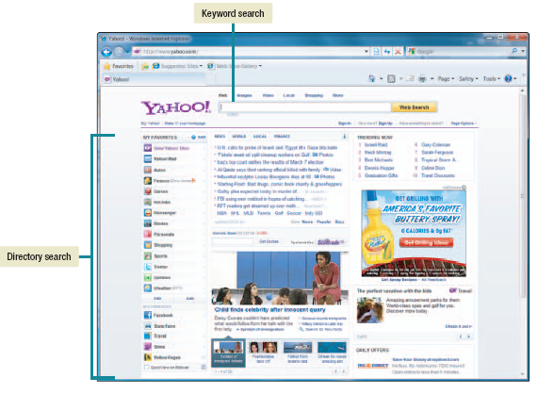

**Figure 2.3 Yahoo’s search engine**

**Table 2.3: References, databases and subject directories among others**

|  |  |
| --- | --- |
| **SITE** | **CONTENT** |
| Britannica.com  Encyclopedia.com  Dictionary.net  Refdesk.com  Infomine (infomine.ucr.edu)  AllWords (allwords.com)  whatis.com (whatis.techtarget.com)  BUBL (bubl.ac.uk)  Google Directory (directoryresources.org)  Open Directory Project (dmoz.org)  The Scout Archives  Intute (intute.ac.uk)  allacademic.com  Academic Info  SciCentral (scicentral.com)  Wikipedia | Encyclopedia Britannica and Internet Guide  Features more than 100 trusted sources, including encyclopedia, dictionaries and thesauruses  Word and phrase definitions from a variety of dictionary resources  Links to facts, encyclopedias, dictionaries, news  Extensive index of scholarly Internet resources  Find a word if you only part of it  Dictionary of Computer Terms  A catalogue of all academic subject areas  The Web organized by topics into categories  The most comprehensive human edited directory of the Web  Search or browse subject-specific database. It contains over 26,000 critical annotations of carefully selected Internet sites and mailing lists  Directory of study and research resources  Journals and other free academic content  Online degree programs and subject guide  Science sites  Community written encyclopedia |

**2.5.2 Metasearch engines**

Metasearch enginesare programs that automatically submit your search request to several search engines simultaneously. The metasearch engine receives the results, eliminates duplicates, orders the hits, and then provides the edited list to you.

There are several metasearch engines available on the Web. Some of them are:

|  |  |
| --- | --- |
| **Metasearch Service** | **Site** |
| MetaCrawler  Dogpile  Search  Ixquick  Clusty | www.metacrawler.com  www.dogpile.com  www.search.com  www.ixquick.com  [www.clusty.com](http://www.clusty.com) |

**Table 2.4: Metasearch sites**

**2.5.3 Specialized search engines**

Specialized search enginesfocus on subject-specific Web sites. Specialized sites can potentially save you time by narrowing your search.

|  |  |
| --- | --- |
| **Topic** | **Site** |
| Environment  Fashion  History  Law  Medicine | www.eco-web.com  www.infomat.com  www.historynet.com  www.llrx.com  [www.medsite.com](http://www.medsite.com) |

**Table 2.5: Some specialized search sites**

**2.6 Searching the Internet**

Information is everywhere on the Internet, existing in large quantities and continuously being created and revised. This information exists in a large variety of kinds (facts, opinions, stories, interpretations, statistics, etc) and is created for many purposes (to inform, persuade, sell, present a viewpoint, create or change an attitude or belief, etc). For each of these various kinds and purposes, information exists on many levels of quality or reliability. It ranges from very good to very bad and includes every shade in between. Unlike most traditional information media (books, magazines, organizational documents), no one has to approve the content before it is made public. It is your job as a searcher, then, to evaluate what you locate.

Before you begin searching, you first need a little understanding about how information is stored and accessed on the Web. There are three categories of information on the Web.

* **The free, visible Web**: This category includes all the publicly mounted Web pages. These pages are indexed by search engines. To find information from this category, use a good search engine or directory.
* **The free, invisible Web**: This category includes the contents of sites that provide their articles or information free to users, but that content may be accessible only by going directly to the site. In other words, search engines cannot index it. Some magazines, newspapers, reference works, and other sites like Facebook, Twitter, etc are in this category. Many databases such as legal, medical, and financial are here, too. To find information from this category, you must go to the appropriate database.
* **Paid database over the Web**: This category includes commercial databases that libraries subscribe to, containing scholarly journals, newspapers, court cases and the like. Providers like Lexis-Nexis, UMI Proquest, Infotrac, JSTOR and others are in this group. To find information from this category, you must have access to the database (through password) and search on the database directly.

**The invisible Web (Deep Web)**

The deep Web refers to World Wide Web content that is not part of the surface Web, which is indexed by standard search engines. It is the vast reservoir of information stored in databases and sometimes dynamically generated only upon request, making it inaccessible to search engine, subject directories, and even intuitive searches. The deep Web is estimated to be approximately 550 times larger than the visible or service Web. In other worlds, 99.8% of the Web content is unavailable to traditional search engines.

**2.7 Electronic commerce**

E-commerce is the buying and selling of goods over the Internet. Shopping on the Internet is growing rapidly because it provides incentives for both buyers and sellers.

From the buyer’s perspective, goods and services can be purchased at any time of day or night. Traditional commerce is typically limited to standard business hours when the seller is open. Additionally, buyers no longer have to physically travel to the seller’s location.

From the seller’s perspective, the costs associated with owning and operating a retail outlet can be eliminated. Another advantage is reduced inventory. Traditional stores maintain an inventory of goods in their stores and periodically replenish this inventory from warehouses. With e-commerce, there is no in-store inventory and products are shipped directly from warehouses.

There are 3 basic types of e-commerce

(1) **Business-to-consumer** (**B2C**) involves the sale of a product or service to the general public or end user. It eliminates the middlemen by allowing manufactures to sell directly to customers. Existing retail stores use B2C to reach customers.

It is the fastest-growing type of e-commerce today. The three most widely used B2C applications are for online banking, financial trading, and shopping.

(2) **Consumer-to-consumer** (**C2C**) involves individuals selling to individuals. It often takes the form of an electronic version of classified ads or an auction.

A recent trend in C2C e-commerce is the growing popularity of **Web auctions**. Web auctionsare similar to traditional auctions except that buyers and sellers seldom, if ever, meet face-to-face. Sellers post descriptions of products at a Web site and buyers submit bids electronically.

There are two basic types of Web auction sites:

* **Auction house sites** sell a wide range of merchandise directly to bidders. The auction house owner presents merchandise that is typically from a company’s surplus stock. These sites operate like a traditional auction, and bargain prices are not uncommon. Auction house sites are generally considered safe places to shop.
* **Person-to-person auction sites** operate more like flea markets. The owner of the site provides a forum for numerous buyers and sellers to gather. While the owners of these sites typically facilitate the bidding process, they are not involved in completing transactions or in verifying the authenticity of the goods sold. Buyers and sellers need to be cautious.

The most popular Web auction sites are:

|  |  |
| --- | --- |
| **Organization** | **Site** |
| Amazon  WeBidz  eBay  Overstock | www.auctions.amazon.com  www.webidz.com  www.ebay.com  auctions.overstock.com |

**Table 2.6: Web auction sites**

(3) **Business-to-business** (**B2B**) involves the sale of a product or service from one business to

another. This is typically a manufacturer-supplier relationship. The most popular B2B e-

commerce is for automobile parts, electronics including computer parts, and health care.

**Web storefronts**

Web storefronts are virtual stores for B2C e-commerce. Shoppers visit the stores on the Web to inspect merchandise and make purchases. Some of the most popular Web storefronts are:

|  |  |
| --- | --- |
| **Description** | **Site** |
| Books  Music  Computers and more | www.amazon.com  www.cdnow.com  [www.ncbuy.com](http://www.ncbuy.com) |

**Table 2.7: Popular Web storefronts**

**Security**

The single greatest challenge for e-commerce is the development of fast, secure, and reliable payment methods for purchased goods. The three basic payment options are check, credit card, and digital cash.

**2.8 Cloud computing**

Application programs are owned by individual or organizations and stored on their computer system’s hard disks. **Cloud** **computing** uses the Internet and the Web to shift many of these computer activities from the user’s computer to other computers on the Internet. It has the following advantages:

1. It serves as a means of marketing new products around the globe.

2. It frees users from owning, maintaining, and storing software and data.

3. It provides access to these services from anywhere through Internet connection.

The basic components of cloud computing are clients, the Internet, and service providers.

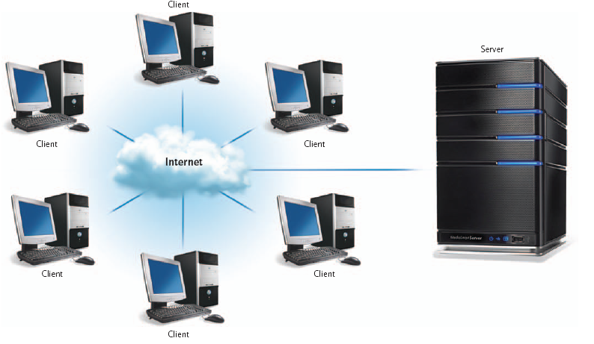

**Figure 2.4: Cloud computing**

* **Client:** Clients are corporations and end users who want access to data, programs, and storage. This access is to be available anywhere and anytime that a connection to the Internet is available. End users do not need to buy, install, and maintain application programs and data.
* **Internet:** The Internet provides the connection between the clients and the providers. Two of the most critical factors determining the efficiency of cloud computing are (1) the speed and reliability of the user’s access to the Internet and (2) the Internet’s capability to provide safe and reliable transmission of data and programs.
* **Service provider:** Service providers are organizations with computers connected to the Internet that are willing to provide access to software, data, and storage. These providers may charge a fee or may be free. For example, Google Apps provides free access to programs with capabilities similar to Microsoft’s Word, Excel, and PowerPoint.

**2.9 Web utilities**

Web utilitiesare programs that make using the Internet and the Web easier and safer. Some of the utilities are Internet services for connecting and sharing resources over the Internet. Some of these utilities are browser-related programs that either become part of your browser or are executed from your browser.

**2.9.1 Plug-ins**

Plug-insare programs that are automatically started and operate as a part of your browser. Many Web sites require you to have one or more plug-ins to fully experience their content.

Some widely used plug-ins include:

* Acrobat Reader from Adobe—for viewing and printing a variety of standard forms and other documents saved in a special format called PDF.
* Windows Media Player from Microsoft—for playing audio files, video files, and much more.
* QuickTime from Apple—for playing audio and video files.
* RealPlayer from Real Networks—for playing audio and video files.
* Shockwave from Adobe—for playing Web-based games and viewing concerts and dynamic animations.

Some of these utilities are included in many of today’s browsers and operating systems. Others must be installed before they can be used by your browser.

**2.9.2 Filters**

Filtersblock access to selected sites. Filter programs allow parents as well as organizations to block out selected sites and set time limits. Additionally, these programs can monitor use and generate reports detailing the total time spent on the Internet and the time spent at individual Web sites, chat groups, and newsgroups. Some well-known filters include CyberPatrol, Cybersitter, and Net Nanny.

**2.9.3 File transfer utilities**

With file transfer utility software, you can copy files to your computer from specially configured servers. This is called **downloading.** You can use file transfer utility software to copy files from your computer to another computer on the Internet. This is called **uploading.** Three popular types of file transfer are **file transfer protocol** (FTP), **Web-based**, and **BitTorrent**.

**2.9.4 Internet security suite**

An Internet security suiteis a collection of utility programs designed to maintain your security and privacy while you are on the Web. These programs control spam, protect against computer viruses, provide filters, and much more. Two of the best-known Internet security suites are **McAfee’s Internet Security** and **Symantec’s Norton Internet Security**.

**2.9.5 Offline browsers**

In order for a Web page to appear on your screen, its HTML document has to be downloaded from the Web site to your computer and executed. When the Internet is busy and/or the document is large, you spend a fair amount of time waiting. Offline browsers, also known as **Web-downloading utilities**, are programs that automatically connect to selected Web sites, download HTML documents, and save them to your hard disk. You can view the Web page later without being connect to the Internet. Two popular off-line browsers are InContexct FlashSite and Teleport Pro.